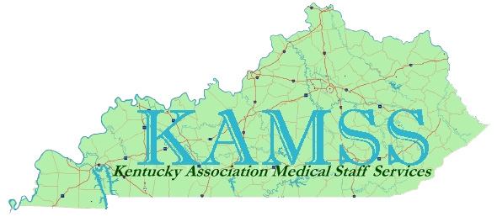

KAMSS 17th Annual Education Conference

**“Charting the Course for Excellence”**

***Friday, May 12, 2017***

**Baptist Health Louisville**

**Education Center**

**Louisville, KY**

***Continuing Education Credits - application will be made to NAMSS***

***for 7.5 hours of Category I CEUs.***

Conference Agenda/Program Information

**“Charting the Course for Excellence”**

**7:30 - 8:00 am Registration and Continental Breakfast**

**8:00 – 8:10 am Welcome and Introductions – Betty Grieshaber, CPCS**

**8:10 – 9:30 am “Quick, There it Goes! The Medical Staff as it Was,**

**Is and Will Soon Be”**

**Speaker: Hugh Greeley, HG Healthcare Consultants, LLC**

**9:30 – 10:30 am “Avoiding Orange as the New Black for Medical Staff Managers:**

**Defending Challenges to Your Credentialing Decisions”**

**Speaker: Charles J. “Mike” Cronan, IV**

**Attorney at Law, Stites & Harbison, PLLC**

**10:30 – 10:40 am Break**

**10:40 - 11:30 am “Lighten Up and Live (Getting and Keeping a Balance)”**

**Speaker: Jeanne E. Sexson BA, MA, MA Cert-Ed**

**JE Sexson Enterprises**

**11:30 - 12:15 am Hot Buffet Lunch provided by Terri Lynn’s Catering by Design**

**12:15 – 1:15 pm “Don’t Squat with Your Spurs On”**

**Speaker: Jeanne E. Sexson BA, MA, MA Cert-Ed**

**JE Sexson Enterprises**

**1:15 – 2:15 pm “Accreditation Update: What’s New, What’s Not and Who Cares”**

**Speaker: Hugh Greeley, HG Healthcare Consultants, LLC**

**2:15 – 2:25 pm Break**

**2:25 – 3:25 pm “Some Things Never Change: Guarding the Gate without**

**Creating Credentialing Complexity”**

**Speaker: Hugh Greeley, HG Healthcare Consultants, LLC**

**3:25 – 4:25 pm “Your Link to MSPs From Across the Nation”**

**Speaker: Rhonda M. Boyd, CPCS, CPMSM, VHA-CM**

**NAMSS Director At Large**

Speaker Profiles

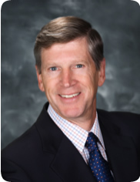**Hugh P. Greeley, HG Healthcare Consultants, LLC**

Hugh Greeley is managing director for HG Healthcare Consultants and is the founder of the Greeley Company. Mr. Greeley is well known to medical staff professionals - he's been around for many years conducting seminars, publishing books and newsletters, speaking at NAMSS conferences and as faculty at the Estes Park Institute, Governance Institute, and many other associations and societies. He counts nearly 4,000 seminars for which he has spoken.  Hugh has worked in nearly a dozen foreign countries and has visited over 1,000 hospitals in the United States.

He has worked with many of our Kentucky hospitals and medical staffs over the past three decades, and that each of us, no doubt, has publications authored by Hugh in our offices.

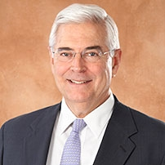

**Charles J. (Mike) Cronan IV, Stites & Harbison, PLLC**

Mike Cronan is a member and former managing partner (1994-1997) of the firm. His practice focuses on civil litigation, with emphasis on business and complex litigation, health care law, and alternative dispute resolution. His recent assignments include co-counsel for plaintiff in a successful federal district court Lanham Act lawsuit for infringement of a registered trademark and false designation of origin, representation of an international company on equipment obsolescence and product liability issues, and representation of hospital medical staffs and physicians in peer review matters, including successful defense affirmed on Sixth Circuit appeal involving a physician's antitrust lawsuit challenging hospital's denial of his clinical privileges.

After graduating from law school in 1970, until 1974 when he joined Stites & Harbison, Mr. Cronan served as a Lieutenant, Judge Advocate General's Corps, USNR, at the law center for the Eleventh Naval District, San Diego, California, and in the Office of Staff Judge Advocate, Commander Cruiser Destroyer Forces, Pacific.

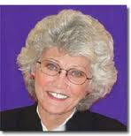

**Jeanne Elizabeth Sexson**

Jeanne Elizabeth Sexson holds a Master’s degree with emphasis in psychology and a Master’s Certification in Education. For over 28 years, she has traveled in and out of the continental United States speaking at national, state and regional conventions where audiences often rate her “best speaker of the conference.” She has been keynote speaker at awards, recognition, and special event banquets and facilitates training for large corporations and individual facilities. Her background includes facilitating leadership training for the University of Evansville, University of Southern Indiana and Indiana Technical State College where she received the Outstanding Adjunct Teaching Award.

She was recipient of both the “EDIT IT” Book Award for Commitment to Achieving Precision in Communication and Mid-America Publisher’s Association Award for Illustrating.

Her honors and recognitions include Outstanding Creative Woman of the Year and recipient of the National Mental Health Association’s Outstanding Service Award. Jeanne is also an accomplished sculptor and photographer.



***Rhonda M. Boyd, CPCS, CPMSM, VHA-CM***

***2017 NAMSS Director at Large (KY, NC, PA, VA, WV)***

Mrs. Boyd is a seasoned medical services professional who is a Health System Specialist for the Department of Veterans Affairs in Durham, NC.  She has served her home state of North Carolina on the Executive Board of NCAMSS and is now serving as liaison on the NAMSS Board of Directors.

Conference Sponsors

On behalf of KAMSS, the Education Committee would like to thank the following sponsors:



Centralized Application Processing Service

[](http://www.namss.org/)

Conference Vendors

On behalf of KAMSS, the Education Committee would like to thank the following vendors:

 



**Thank You for Supporting the KAMSS 17th Annual Education Conference!**

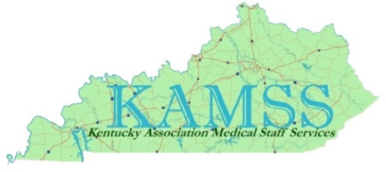

Driving Directions & Hotel Information



**Baptist Health Louisville Education Center**

**Auditorium (2nd floor)**

**4000 Kresge Way**

**Louisville, KY 40207**

**Driving Directions:**

**From I-64**

I-64 to Exit 12A Watterson Expressway West. Take the next exit, Breckenridge Lane North, Exit 18B. Turn North off the exit ramp onto Breckenridge Lane. Proceed North through the traffic lights at Dutchman's Lane and Dupont Road. Turn right at the third traffic light onto Kresge Way.

**From Watterson Expressway**

Take Watterson Expressway to Breckenridge Lane North, Exit 18B. Turn North off the exit ramp onto Breckenridge Lane. Proceed North through the traffic lights at Dutchman's Lane and Dupont Road. Turn right at the third traffic light onto Kresge Way.

**From I-65**

I-65 to Watterson Expressway East, Exit 131. Proceed East on Watterson Expressway until you reach Breckenridge Lane North, Exit 18B. Turn North off the exit ramp onto Breckenridge Lane. Proceed North through the traffic lights at Dutchman's Lane and Dupont Road. Turn right at the third traffic light onto Kresge Way.

**Hotel Information:**

**Hawthorn Suites**

451 Cypress Station Drive, Louisville, KY 40207

Toll free - 866-899-5959 / Local - 502-899-5959

**KAMSS negotiated price of $99 + tax per night.**

**Mention you are with the KAMSS conference.**

**Reservation cut-off date is April 20, 2017.**

Registration Form



***Kentucky Association of Medical Staff Services***

***17th Annual Education Conference***

***Friday, May 12, 2017 – Baptist Health Louisville***

***8:00 am – 4:30 pm***

**Registration Fees**

**$90.00 - KAMSS members $145.00 - Non-members**

**Registration Form**

Name__________________________ _____________________________________________

Title _____________________________ Hospital/Institution________ _____________________­­­­­___________

Address____________ ________________________________________________

City________________ ________________ State _______ Zip______ _______

Phone_____________________________________________E-mail_____________________ _______________

**Make checks payable to KAMSS and send payment and registration to:**

**Kentucky Association Medical Staff Services**

**P.O. Box 32132**

**Louisville, KY 40232**

Registration is limited to 225 participants.

**Registration deadline: postmarked on or before May 1, 2017.**

Confirmation of registration will be emailed.

*All cancellations will incur a $15.00 processing fee.*

*No refund if cancellation request is received after May 1, 2017.*

Contact: Betty Grieshaber, CPCS at 502-643-5174 or via email at [bgrieshaber@bhsi.com](mailto:bgrieshaber@bhsi.com)